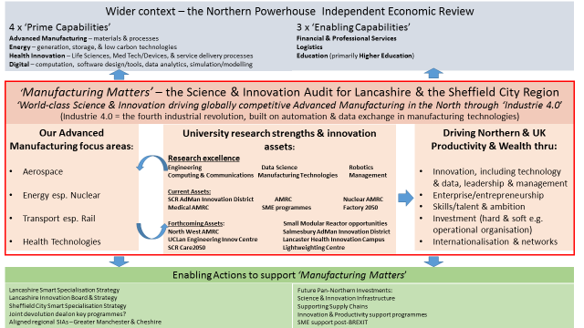
Source: SQW, Sheffield City Region and Lancashire
The conclusion to the SIA is formed on an assessment of the complementary science and innovation assets and excellence in translational capabilities combined with the sound industrial base that can be built upon, sets a series of ‘asks’ to Government for the significant investment that will be required to drive a transformational change in the productivity performance of the region.
These major potential pan-Northern initiatives will build upon the more localised current and emergent physical and revenue proposals that will become significant enablers of, and pathways to, the bigger programmes that are built on the combined power of Lancashire and Sheffield City Region and the orchestration our complementary strengths and assets to firmly establish the North as a global leader in advanced manufacturing into the long term.
Our suggestions will need to feed into and compliment the Government’s new industrial strategy and the direction this will take on making strong connections between industries and places, together with a link drawn through towards future devolution agreements and consideration of the potential for a future joint Lancashire-Sheffield City Region devolution deal on key priorities.
These are categorised as below:
- Capital Science & Innovation infrastrucutre: Establish the Northern Advanced Manufacturing Innovation Corridor from Sheffield’s AMRC/Advanced Manufacturing Innovation District, with emergent opportunities around a light-weighting centre, a robotics and autonomous systems Catapult and strengthened links to the Turing Institute, to the proposed NWAMRC at the Salmesbury EZ and its evolution into the Lancashire Advanced Manufacturing Innovation District, linking in UCLan’s Engineering Innovation Centre, national assets via the AMRC relationship to the High Value Manufacturing Catapult, Lancaster’s proposals to develop a new research centre on joining technology with TWI and a linked £30m HEFCE Research Partnerships Investment Fund bid in this regard with BAE as a key partner, cementing the link between the Sheffield Medical AMRC and Lancaster’s Health Innovation Campus and the development of this over three phases, the Nuclear AMRC through to the Springfields and Small Modular Reactor developments (and reach into Cumbria).

- Northern Innovation Support programme(s): building upon our collective leading existing and emerging innovation programmes that are advanced manufacturing /engineering focused and drawing in the complimentary disciplinary areas of digital, data science, cyber security, robotics, eco-innovation, health and care, management innovation, etc, linking together the corporate and SME agendas on building better and stronger supply and value chains. Explore the potential for Northern nuclear supply chain productivity/innovation support programme focused on the SMR opportunity.

Given BREXIT and the particularly strong historical reliance on delivering such programmes through ERDF and through trans-national innovation and research partnerships, it is critical that Government find other sources of future finance to enable the above in this context.

- Talent - skills, leadership and management, attraction and retention: a pan-Northern skills programme to support the requirements of advanced manufacturing businesses, those in the wider complimentary aligned sectors and emergent new skills needs driven by Industry 4.0, supporting the replacement agenda for highly technical skills and risks around an ageing workforce, exciting the younger generation around the new advanced manufacturing and associated value chain career opportunities and stimulating the enterprising and entrepreneurial ambition and talent pipeline. Programmes that better enable us to retain but also attract the very best talent to the region and respond to the critical need to support the retention in the region of our STEM talent and meet the needs of industry to mitigate the growing skills gaps. New enterprise support for advanced manufacturing and linked industries to create the ambitious entrepreneurs and high growth businesses of the future.

Establish a Northern Productivity Academy to drive the transformational leadership and management change required to make a significant impact on the region’s productivity. This builds on Lancaster’s involvement through our partnership with BAE on the Government’s Productivity Leadership Group and a pilot leadership for productivity programme under development. This to be underpinned by a strong research agenda and plans at Lancaster to establish a world-leading trans-disciplinary Productivity Research Centre in the Management School and building upon Lancaster’s involvement through our work with BAE on the Productivity Leadership Group (and a pilot programme under development.

- Support for Internationalisation and how we can best exploit regional Higher Education and industrial networks and partnerships for broader benefit, working with the LEPs, UKT&I, etc. Explore the potential for a Northern Catalyst Programme building on the Lancaster China Catalyst Programme and Sheffield City Region internationalisation programmes.
All of the above further arises through direct consultation with key industrialists from across the best large and small firms in the North and resonates strongly with a recent report by the North West Business Leadership team focused on productivity that made three recommendations to Government to drive the required improvements to close the growing UK productivity gap with international competitor nations:
- Promote leadership and ambition, sharing best practice
- Support increased innovation and technology
- Support and encourage local and national government to prioritise productivity

